*AISHWARYA KAGGDAS*

*USER MANUAL*

*Arduino Based touch Free Automatic Hand Sanitizer*

INTRODUCTION :

The Project I have worked on is Arduino Based touch Free Automatic Hand Sanitizer.

PART A : Components that have been used The sensors and actuators that I have used are:

Digital Sensor:

1] Ultrasonic Distance Sensor - HC-SR04.

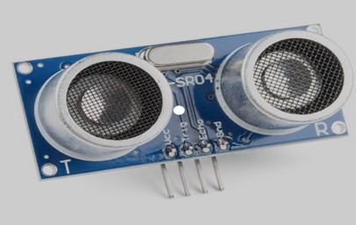

Actuators :

1. LEDS

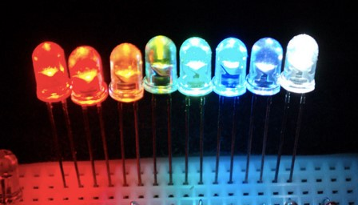

1. Servomotor

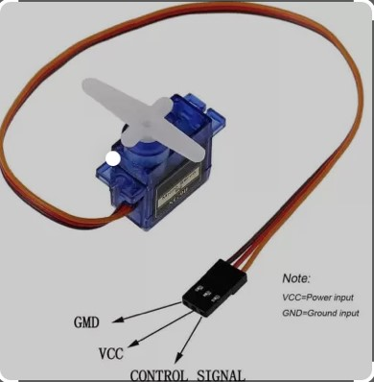

All the other components used are :

1. Arduino UNO

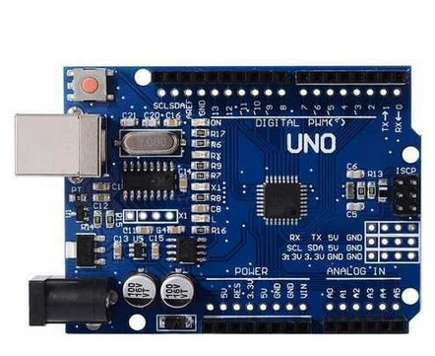

1. Breadboard

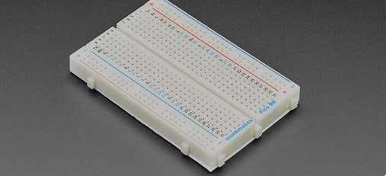

1. Male to male jumper wires

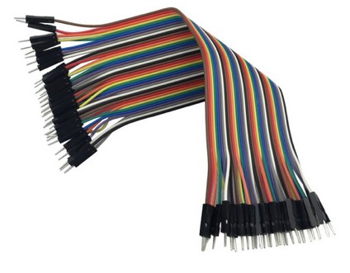

4 ] Hand Sanitizer



Working sketch to facilitate Input/Output and serial communications:

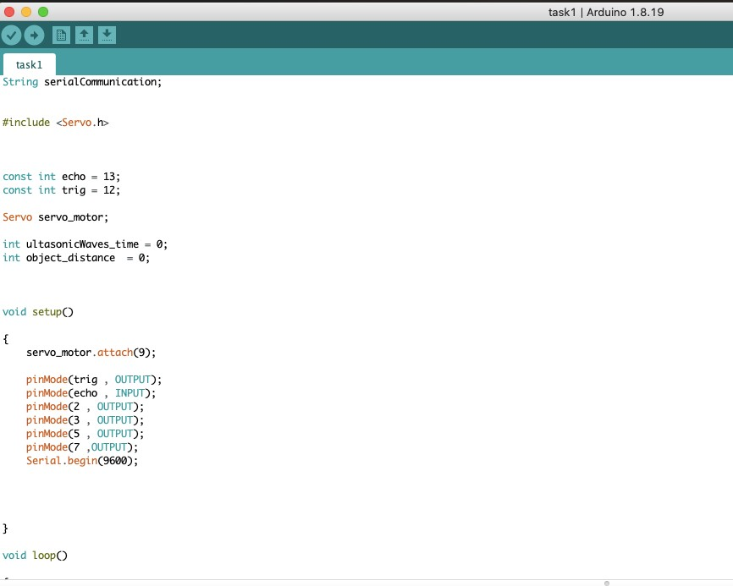





Serial Communication:

1. ] Transmit serial data from IoT node to edge device, so the values recorded by the connected IoT sensors can be sent through a serial port.



1. ] Transmit serial data from edge device to IoT node, so the commands from the edge device can trigger actuators connected to the IoT node.

If the distance is greater than 25 and less than 100 the first two LEDs will blink, else a message will be displayed which says “Please keep your hand closer to the sensor”. This message is displayed when the user’s hand is at a distance greater than 100 or something between 21 to 24 . In both cases the user has to keep his hand closer the senor to use the sanitizer.

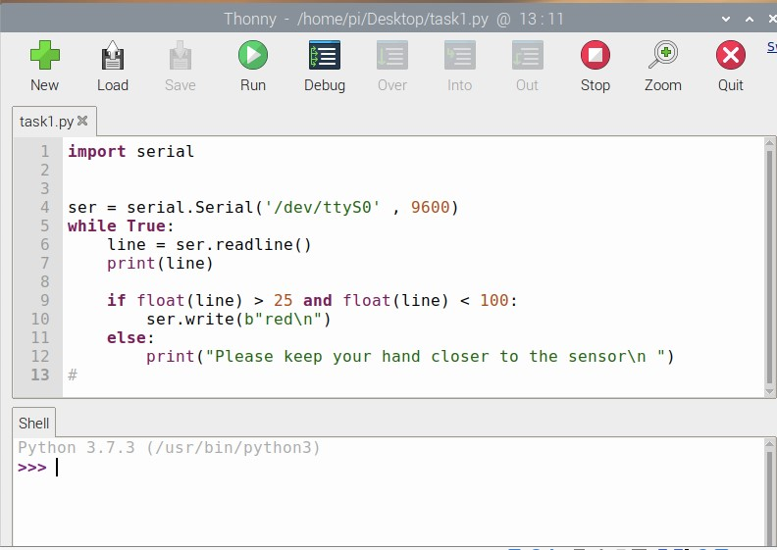

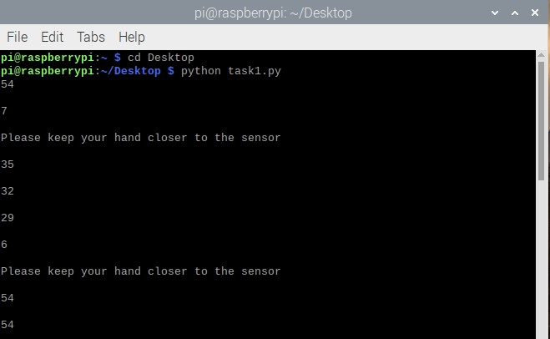

Database implementation and simple analytics:

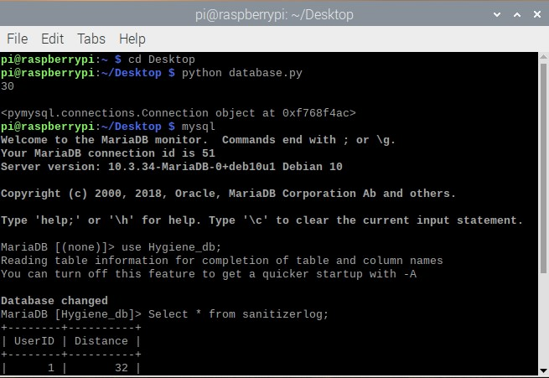

USER INTERFACE:

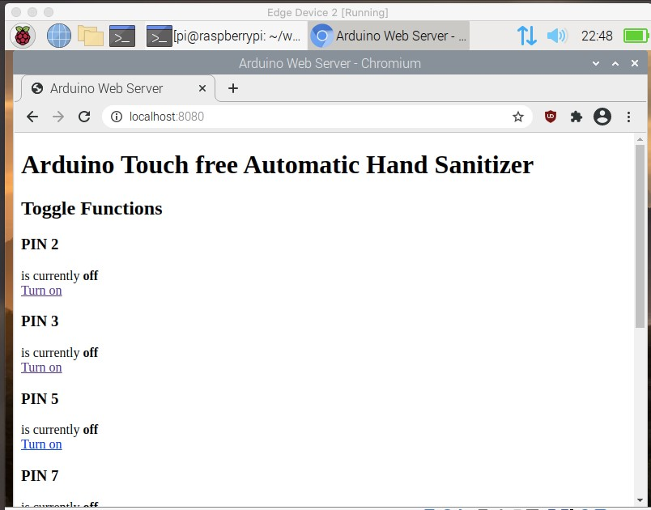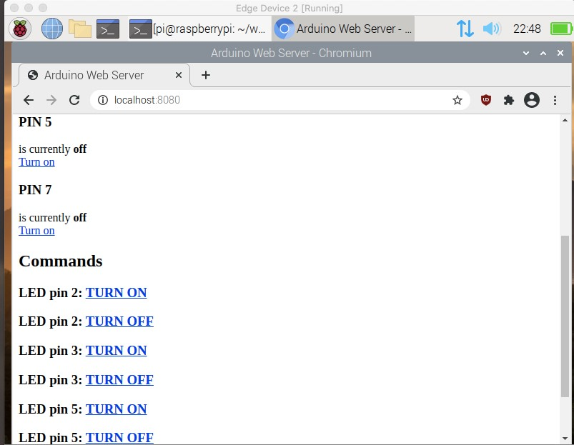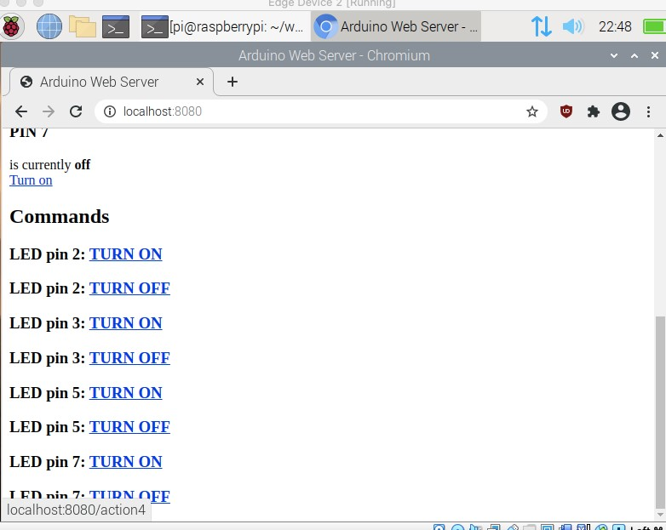

How each component works and how it is integrated with the Arduino.

1. Ultrasonic Distance Sensor - HC-SR04 .The HC-SR04 has four pins:
   * VCC (Power),
   * Trig (Trigger),
   * Echo (Receive),
   * GND (Ground)

It is connected to the breadboard. It has a range of approx. 400 cm. We use 4 male to male jumper wires to connect the ultrasonic sensor to Arduino. The VCC pin of the senor is connected to the 5 voltage supply of Arduino. The Trigger (trig) pin is connected to 12 digital pin of Arduino. The Echo pin is connected to 13 digital pin of Arduino. The GND (Ground) pin of the sensor is connected to the ground of Arduino.

1. LEDs

Four LEDs have been used and they are connected to the breadboard. We use 5 male to male jumper wires to connect the LEDs to Arduino. One jumper wire is used to connect the ground of the Arduino to the short legs of LEDs (cathode) on the breadboard. The positive anode long led of LEDs are connected to the digital pins of Arduino. The first LED is connected to the 2 digital pin of Arduino. The second LED is connected to the 3 digital pin of Arduino. The third LED is connected to the 5 digital pin of Arduino. The fourth LED is connected to the 7 digital pin of Arduino.

1. Servomotor

One servomotor is used . The yellow wire of the servomotor is connected to the 9 digital pin of Arduino ,the red wire of the servomotor is connected to the 5V of Arduino and the black wire of the servomotor is connected to the ground of Arduino.

Software/Libraries:

The library that I have included is Servo because it allows Arduino boards to control a variety of servo motors. This library is capable of controlling a large number of servos. It makes good use of timers: with just one timer, the library can control twelve servos.

Conceptual Design FLOWCHART

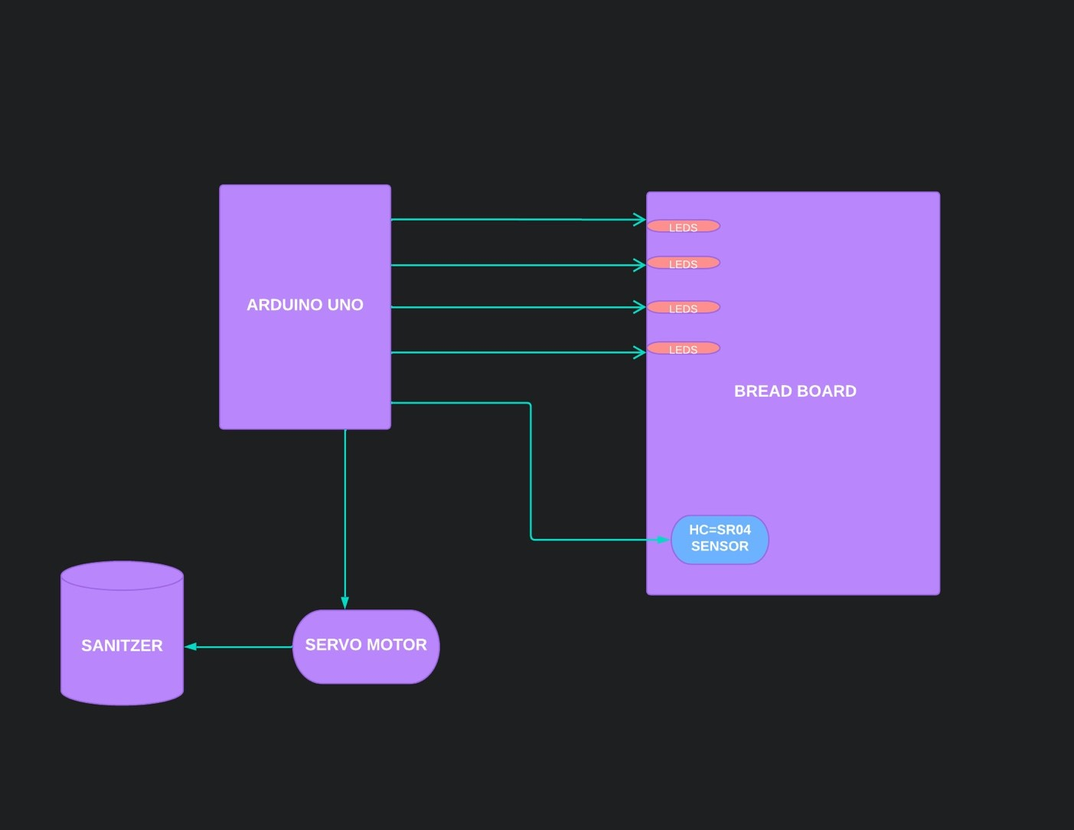

When we get the hand closer to the HC-SR04 sensor , all the LEDs will blink and the servo motor attached to the sanitizer will start working and the user will be able to sanitize his/her hands without touching the sanitizer. If the distance between the hand and the sanitizer is between 25 and 100 , then only the first two LEDs will blink. If the distance is less or equal to twenty then all the LEDs blink and the servo motor also works.

Appendix:

DATABASE :

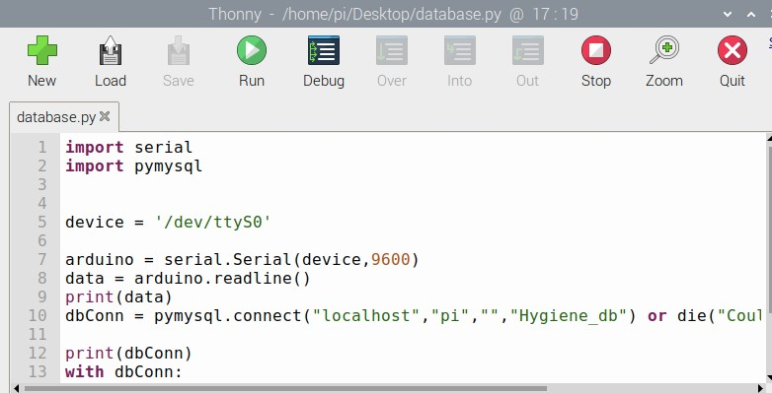

USER INTERFACE

INDEX.HTML

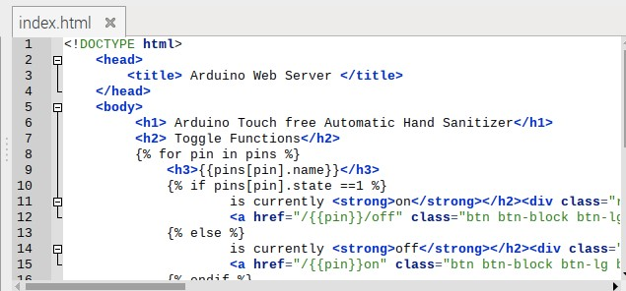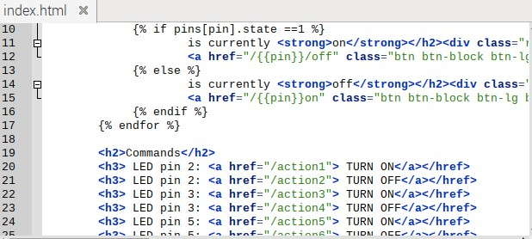

LED_CONTROL.PY

